ITUE203: WEB DEVELOPMENT FRAMEWORKS 25CS106– Yana


Faculty of Technology and Engineering

Chandubhai S. Patel Institute of Technology (CSPIT) Department of Computer Science & Engineering

Laboratory manual
Academic Year | : | 2026-27 | Semester | : | 3rd

Practical - 11

PROBLEM STATEMENT :
Create a student management module to add, view, edit, delete, search and filter student records. All database operations must use MYSQLi statements and clear success/failure messages.
OBJECTIVE:
To develop a Student Management Module using PHP and MySQLi that allows users to add, view, edit, delete, search, and filter student records with appropriate success and failure messages for all database operations.

OUTPUT:
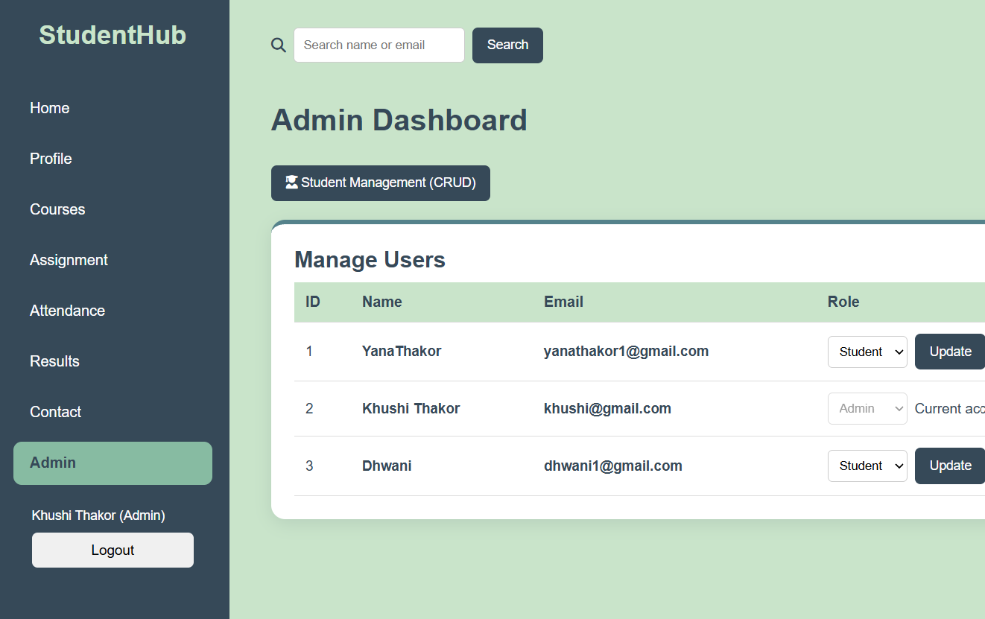

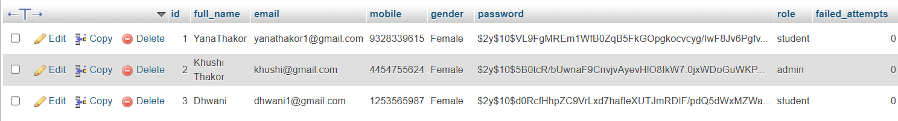

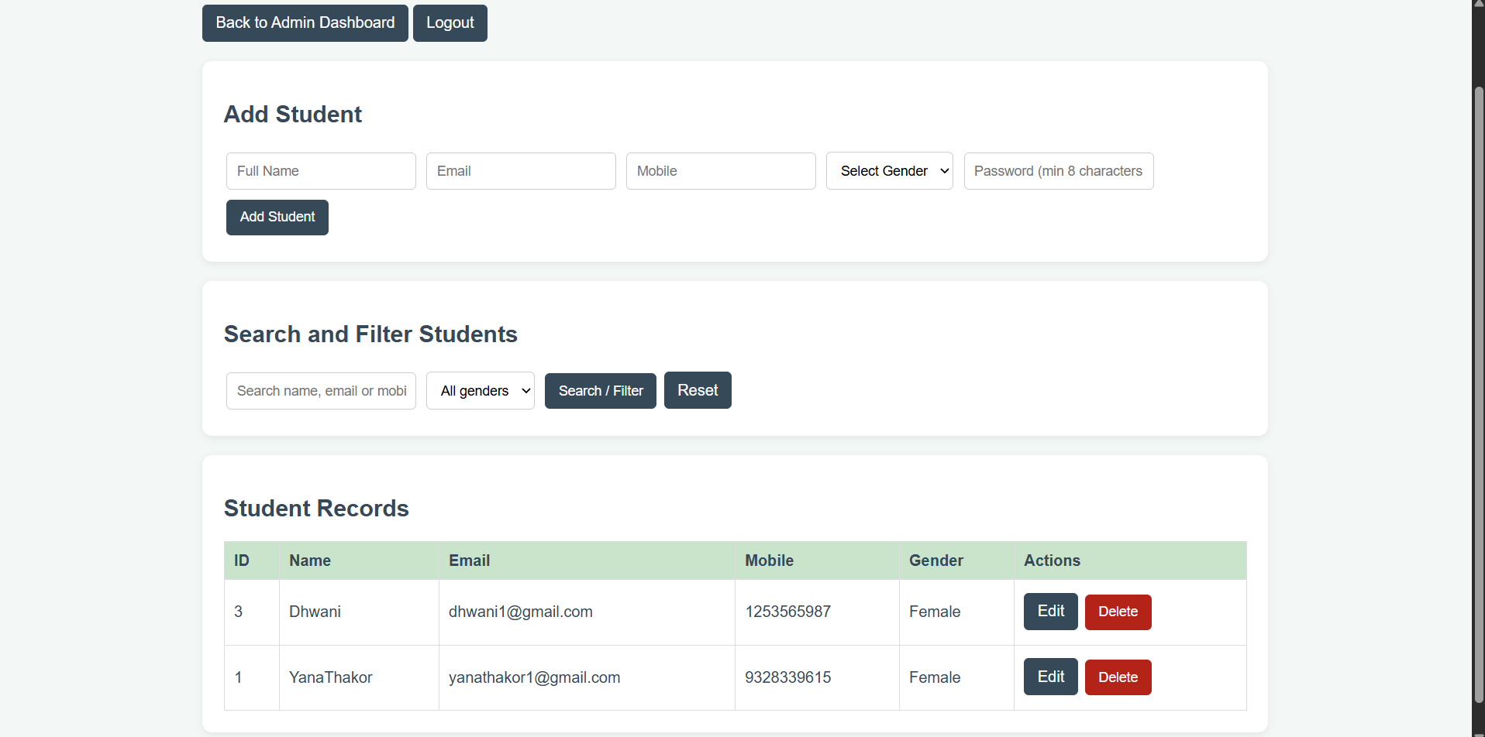
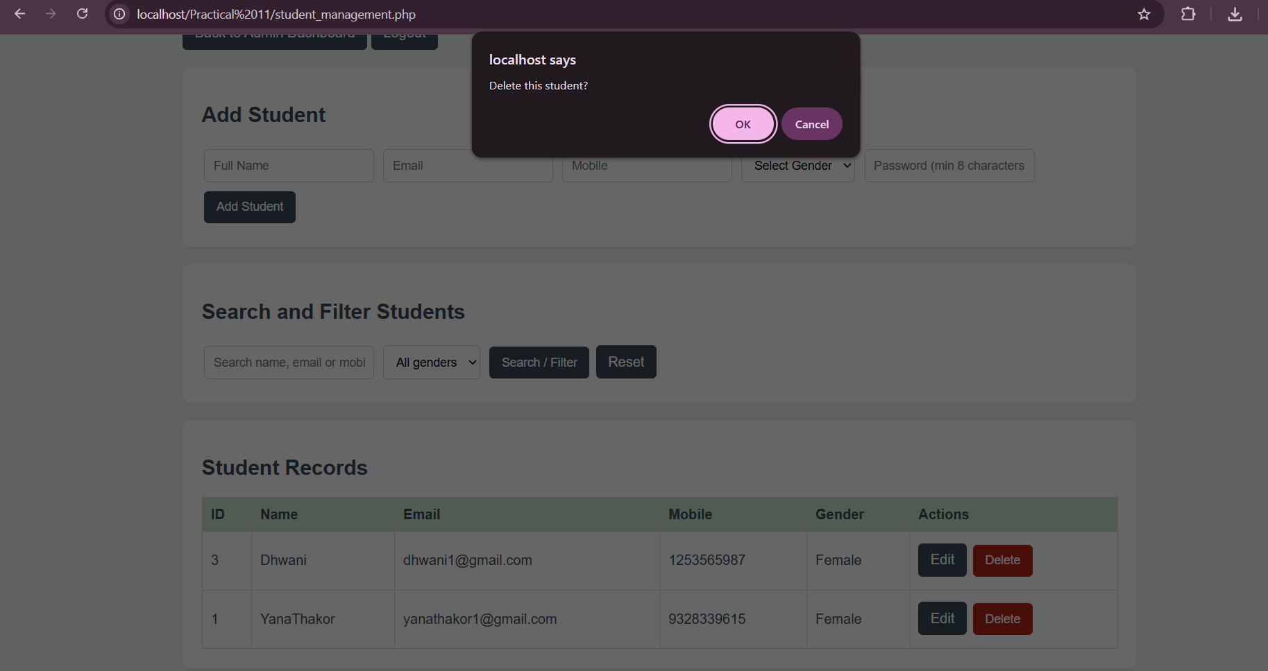
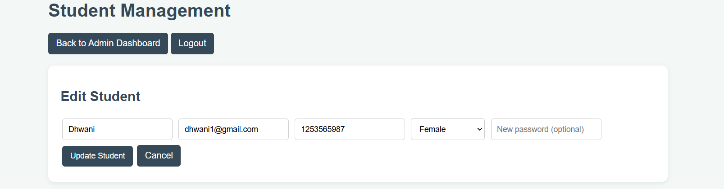
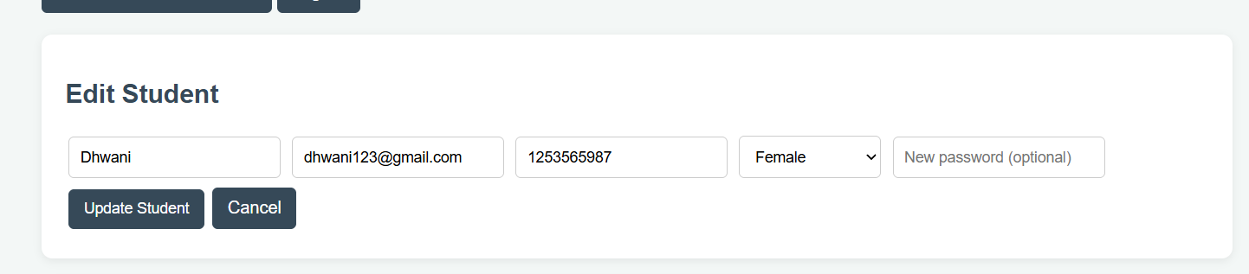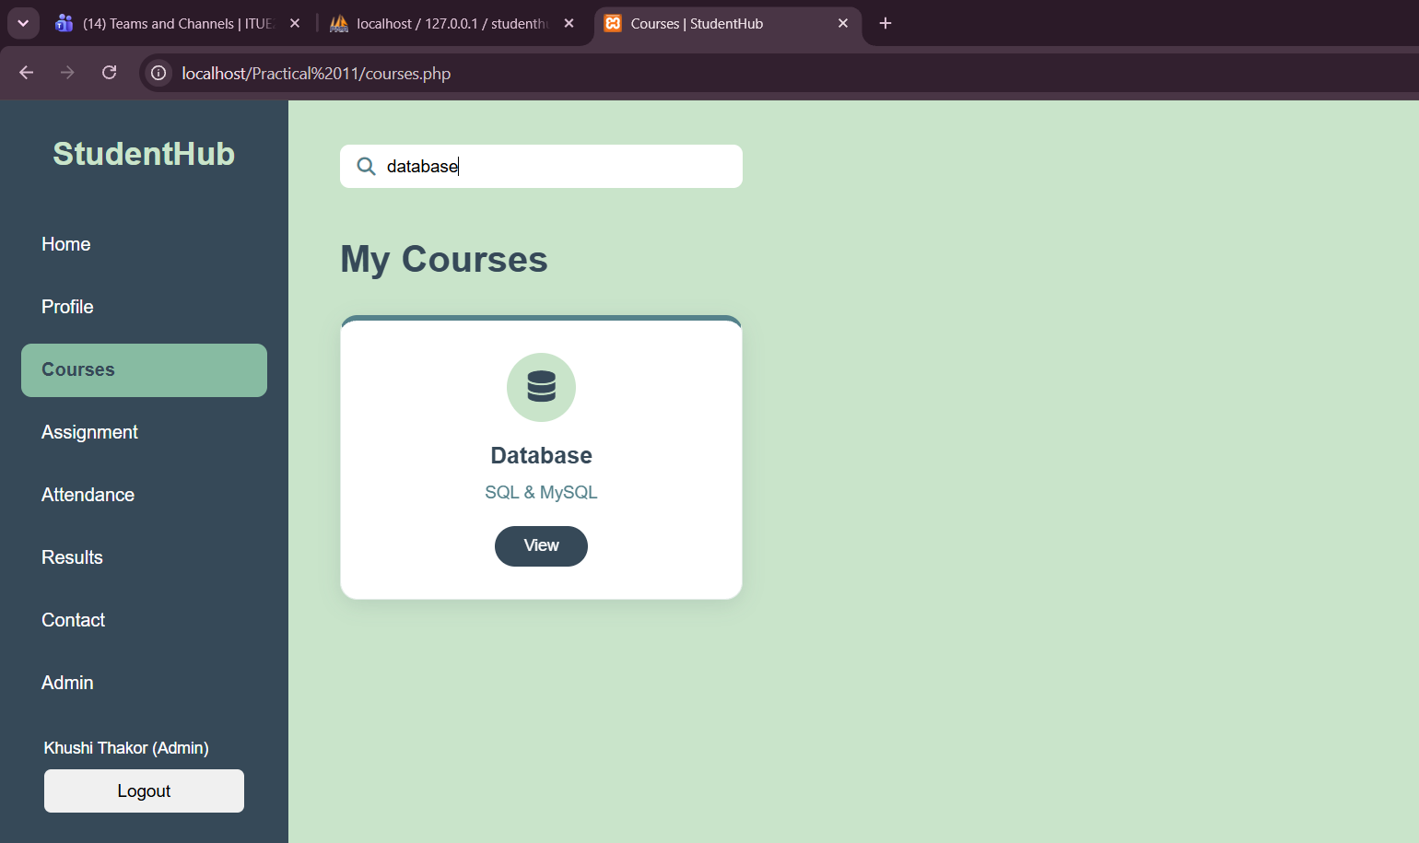
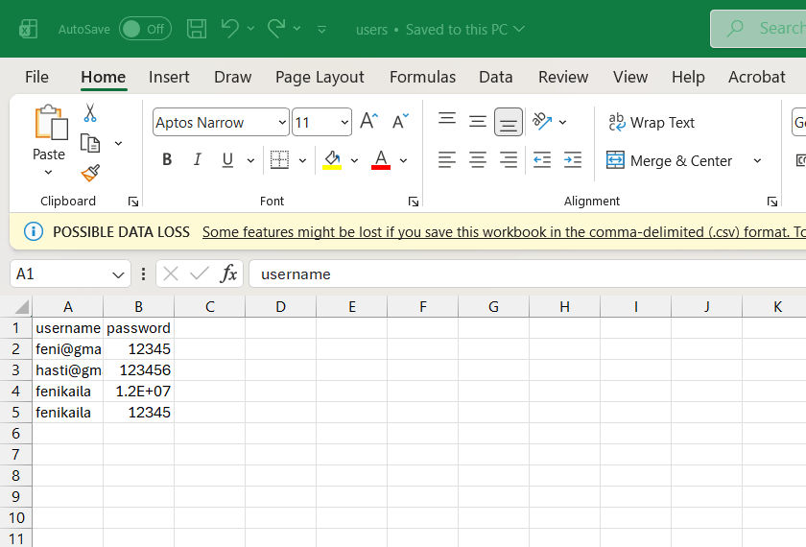
LEARNING OUTCOME:
- Implement CRUD operations (Create, Read, Update, and Delete) using PHP and MySQLi.
- Develop search and filter functionality to retrieve specific student records efficiently.
- Perform database operations using MySQLi statements with proper input validation.
- Display clear success and failure messages for database operations.
- Understand student record management and database interaction in a web application.

